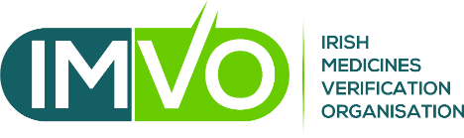

Request from IT Software Provider / System Owner to Connect to Irish Medicines Verification System (IMVS)
Name of company/organisation
Address
Primary technical contact name
Primary technical contact email
Primary technical contact telephone
Requested username
If none is suggested, one will be generated
Name of software system(s) to be connected to IMVS
Who are the end-users of the system(s)?
Community pharmacies, hospital pharmacies, others (please give details)?
I confirm that I am duly authorised to complete this form on behalf of the above named company / organisation:
Name (BLOCK CAPITALS)
Position in organisation
Signature
Date

The signed form should be returned by email to ITManager@imvo.ie. Please note that you are also required to sign a non-disclosure agreement (NDA) with the IMVS provider, Solidsoft Reply Ltd, before access will be granted to the IMVS ITE. The NDA template is available on request from IMVO.

Data privacy: The personal data provided on this form will be processed by IMVO in accordance with our data privacy policy which is available at: http://www.imvo.ie/about/data-privacy-policy. In particular, relevant details will be shared with Solidsoft Reply Limited for the purpose of them providing you with the necessary technical information to create a connection from your system to the IMVS.

